Food & Beverages

Clients & Participants

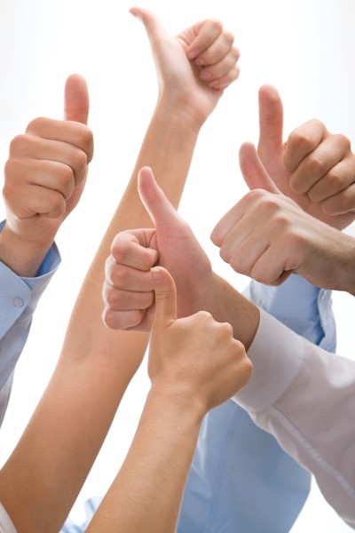

aeschwartz.com schoolformanagers.com

readysetpresent.com

designmyppt.com

aed-is.com

aes@aeschwartz.com

Au Bon Pain Catering

* Bisco Foods
* Convenience Stores Association
* Delmonico's
* Dunkin' Donuts of America, Inc.
* Gardetto's Bakery
* Greylawn Foods Inc.
* Herbalife Nutritional Program
* Hawthorne By the Sea
* Kraft General Foods, Inc.
* Legal Seafoods
* Little Peach
* L.P.M. Holding Company
* M&M / Mars Corporation
* Magic Pan Restaurant
* Marriot Corporation
* Meat Again Inc.
* Michael's Harborside
* Mooring Restaurant
* Newport Harbor Corporation
* Purity Supreme
* Pub Dennis
* Republic Service Mngmnt/Vending
* Rosen Distributing Inc. (Dairy)
* Sara Lee Corporation
* Stowaway Sweets

What Participants Have Said!

I believe I will improve my life and career because of this seminar  Stepping back and thinking about what I am doing first was the most useful technique I learned.

# The Krupp Companies, Edward D. Belz, Assistant Vice President

I am now off on the right track  I look forward to reading material and coming back next week  An excellent mix of lecture and interactive exercises  It all fits together.

# Cape Cod Ice Cream Co., R. Scott Memhard, Manager and V.P.

The presentation was informative and gave good general background for helping to start or plan a business  The session was very relaxed with positive thinking that helped create ideas about what is possible to do with not only business but personal areas as well.

# Legal Seafoods, Susan Butler, Waitress

The seminar leader was excellent  I can think of no suggestions to improve the seminar; it was great.

**Gardetto's Bakery, Jon Mass, Lead Man**